“By any criteria, BREEDPLAN is the Global Beef Leader for Genetic Evaluation”
Don Nicol, Beef Cattle Consultant

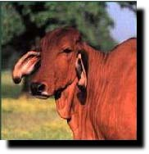

Namibian Brahman Cattle Breeders’ Society

working with

BREEDPLAN International
to promote fertility….growth….carcase yield….breeding value….

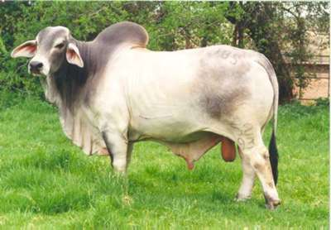

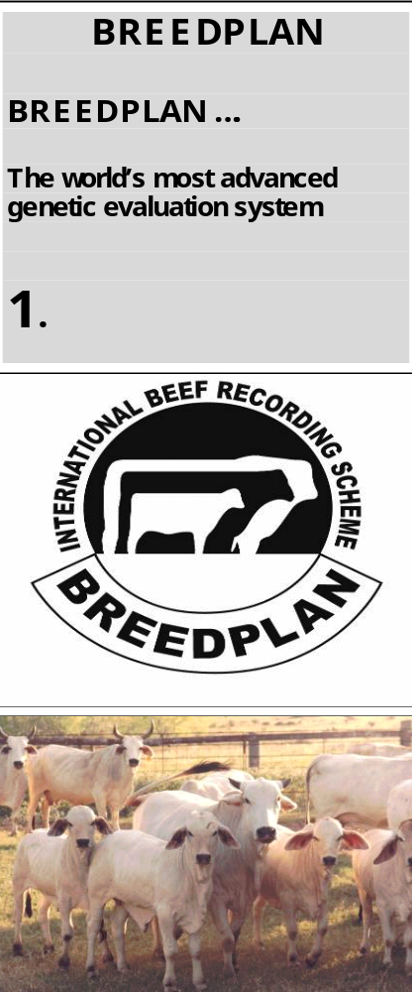 | What is BREEDPLAN?  BREEDPLAN is a modern genetic evaluation system for livestock breeders. It is applied by ABRI to the cattle industries in many countries but it can be customised for other species. BREEDPLAN offers you the potential to accelerate genetic progress in your herd, tighten up your breeding operations, improve productivity and increase the prices of your livestock. It can put a lot more cash in your pocket.  BREEDPLAN uses the world's most advanced genetic evaluation system (ie. an "animal model" which incorporates multi-trait analysis procedures) to produce Estimated Breeding Values (EBVs) of recorded cattle for a range of traits (eg. fertility, weight, carcase).  BREEDPLAN is integrated with the pedigree systems of many breeds. With the increasing use of artificial insemination, most herds within a breed have genetic links with other herds. BREEDPLAN technology can be used at a number of levels eg. within-herd analyses for individual breeders, across-herd analyses for members of a breed association or breeding group and international genetic evaluations where breed associations from a number of countries pool their data for analysis.  BREEDPLAN is the national beef recording scheme in Australia,  New Zealand, Namibia, Thailand and the Philippines. Its use is increasing in the United States, Canada, United Kingdom, Hungary, South America, South Africa and the United Kingdom.  This brochure explains some of the concepts used in BREEDPLAN.

Why should you be in it?

BREEDPLAN takes the guesswork out of selection decisions. You can't see an animal's genes! Two animals might look the same, but genetically they could be quite different. From just looking at a bull you can't tell:
whether his daughters will be good milkers,
how fertile his daughters will be,
how big his calves will be at birth and how they will grow on,
what will be the carcase yield of his progeny.

These are the very factors that determine the profitability of your enterprise. By giving you the EBVs of animals for the factors you can't see, BREEDPLAN takes the guesswork out of your selection program. Pedigree and commercial cattle breeders can accelerate genetic progress and improve profitability. That's why you should be in it.

What is Heritability?
BREEDPLAN
EBV overview

BREEDPLAN EBVs……
are based on the performance
of the animal and all its
recorded relatives

2.

In simple terms heritability is the proportion of the genetic superiority
or inferiority of an animal that is passed on to its progeny.
Heritabilities vary for different traits and breeds, but some commonly
used values are given below, and their use is described opposite.

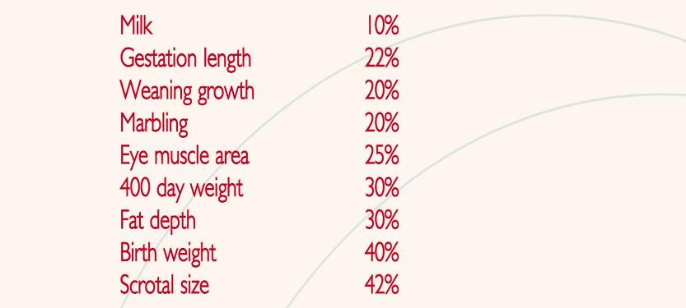

What are EBVs?

An animal's breeding value is its genetic merit, half of which will be passed onto its progeny. While we will never know the exact breeding value, for performance traits it is possible to make good estimates. These are called Estimated Breeding Values (EBVs). They are expressed as the difference between an individual animal's genetics and the genetic base to which the animal is compared. EBVs are reported in the units in which the measurements are taken eg. kilograms for weight. Thus a value of +12kg for 400-day weight means the animal is genetically superior by 12kg at 400 days compared with the genetic base of the relevant cattle population.

GROUP BREEDPLAN EBVs are calculated from all relevant information available in a breed's database. The resultant EBVs provide predictions of the animal's genetics on an across-herd basis. EBVs are the BEST genetic predictions that modern technology can provide.

How is an EBV calculated?

In a simple situation an EBV can be calculated from the records on an animal's performance, the heritability of the trait and knowledge of the genetic base of the population. For example, if an individual animal weighed say 60kg above the average of its contemporaries at 400 days and no other information was available on the performance of relatives, etc its EBV would be calculated as follows:

Performance +60kg

Heritability 30%

EBV 60 x 0.3 = +18kg

BREEDPLAN
EBV overview

Estimated Breeding Values…..
highlight the genetic differences you can’t pick by eye

3.

How is an EBV calculated? (continued)

In real life the calculations become more complicated as in a GROUP BREEDPLAN situation they include:

the animal's own performance
the performance of all known relatives in all herds
the relationship between the different traits
the performance of all herds over all years of recording

That is, there are literally thousands of calculations that go into producing EBVs for every animal in a large performance recorded population.
You can't do these calculations "on the back of an envelope". That's why BREEDPLAN uses a powerful computer to do the job.

BREEDPLAN and GROUP BREEDPLAN results are calculated using software developed by the Animal Genetics and Breeding Unit (AGBU), a joint institute of NSW Agriculture and the University of New England. Meat and Livestock Australia Ltd contributes research funds to these developments.

What EBVs are available?

Subject to available data, BREEDPLAN is able to evaluate EBVs for the following traits:
Some breeds also calculate EBVs for Docility and Net Feed Intake.



What's so good about EBVs?

Consider GROUP EBVs for two sires:

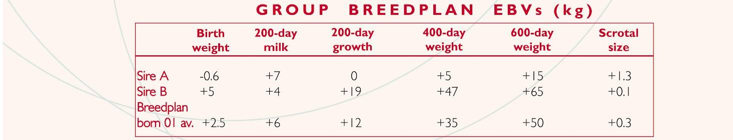

Using the above data and assuming that you have used both sires on groups of cows with similar average EBVs, the 400-day weights of the two sires' progeny would differ considerably. Let's compare the expected performance of progeny of Sires A and B - remembering that in each successful mating the sire contributes 50% to the genetics of the resultant calf. Sire B has an EBV of +47kg at 400 days and so he would be expected to produce calves that were (+47kg less +5kg)/2 = 21kg heavier than those from Sire A (which has an EBV of +5kg). That's worth over R252 per calf – a very good reason for knowing about the EBVs of all your breeding stock. When the EBVs of Sires A and B are compared to breed average, we can also see that Sire B is above average for birth and growth but below average for milk and scrotal size.
BREEDPLAN
EBV overview

Accuracy ……
The more records there are, the greater the reliability of EBVs

4.

How reliable are EBVs?

By definition, EBVs are estimates of an animal's true breeding value.
The estimate is made from analysis of all information that is
available on the animal. Naturally, the more information that is
available the more accurate the estimate will be.

"Accuracy" values are quoted in percentage terms from 0-99 for
BREEDPLAN EBVs. In sale catalogues, for example,
the recommended layout shows the accuracy as a percentage
figure in the box below the EBV.

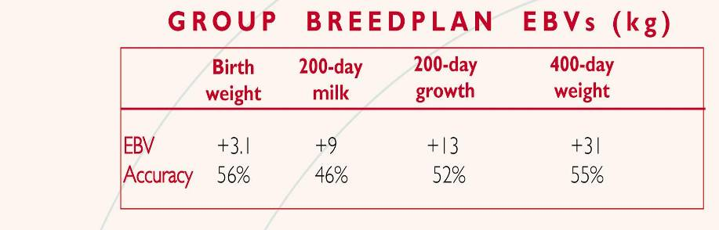

As an example, if the only information is the bull's own measured performance for 400-day weight (a trait with a heritability of 30%), the accuracy of his EBV for that trait will be 55%. If 10 progeny records are added to this analysis the accuracy of his EBV will increase to 76%. The individual's performance plus 45 progeny records give an accuracy of 90%.

The following guides are given for interpreting accuracies:

Accuracy range Interpretation
less than 50% - EBVs are preliminary and could change substantially as more performance information becomes available;

50-74% - medium accuracy, based on the animal's own records and pedigree;

75-90% - medium-high accuracy. Some progeny information included. It is unlikely that EBVs will change much with addition of more progeny data. Use with confidence;

more than 90% - high accuracy estimate of the animal's true breeding value.

As a rule, animals should be compared on EBVs regardless of accuracy. However, where two animals have similar EBVs the one with higher accuracy could be the safer choice, assuming other factors are equal.

What are Within-herd EBVs?
The calculation of Within-herd EBVs is an option available to those breeders who wish to see their data analysed separately. Within-herd EBVs may also be generated from breed societies’ databases if good genetic linkage does not exist between herds. The genetic base for Within-herd EBVs is calculated separately for each herd based on 1000 performance records. The performance of related cattle outside the individual herd is ignored.

Within-herd EBVs are only comparable within the herd for which they are calculated. They are not comparable with GROUP BREEDPLAN or Interim EBVs. They should be confined to within-herd use.

Within-herd EBVs are calculated from performance data in your herd only!

BREEDPLAN
genetics compared

BREEDPLAN ……
Allows you to select for real
genetic differences .

5.

Does BREEDPLAN separate genetics from environment?

Yes! This is a very important feature of BREEDPLAN. When you look at an animal's size, 70% of what you see is the contribution of the environment (eg. feed quality, disease, management etc) - only 30% is due to genetics. But it is only the genetic component that is transmitted from one generation to the next. It is the genetics that makes an animal valuable for breeding - but unfortunately we can't "see" these genetics separately from the environmental influence. However, BREEDPLAN can separate out genetics from the environment and this allows you to select for real genetic differences.

Here's how it is done. Assume that the calves from a particular crop (ie. spring 2002) are managed in two ways. Group 1 is run on good feed and Group 2 on poor feed. Calf A in Group 1 has a 400-day weight of 430kg and calf B in Group 2 has a 400-day weight of 390kg (see Table below). Is calf A genetically better than calf B because it is heavier at the same age?
Not necessarily. The average weight of Group 1 is 420kg, so calf A is just 10kg above average. Calf B is 30kg above the average of Group 2. Calf B is
correctly assessed as being better in its own group. If the two groups were genetically similar, you would find that calf B would have a better EBV than calf A. The higher absolute weight of calf A is due to the better environment. 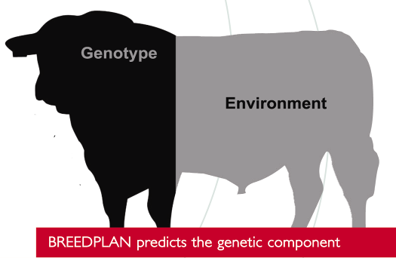
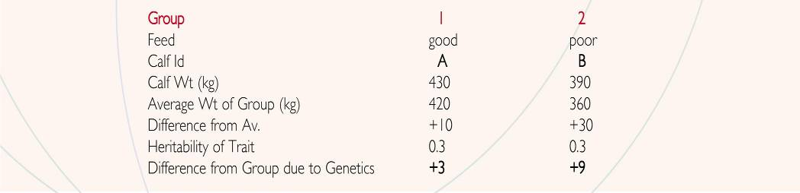
What is a genetic trend?  Because environment is separated out from genetics in the BREEDPLAN evaluation, and the data is analysed over a number of years, it is possible to calculate the genetic trend for each trait. This trend can be calculated for an individual herd or the breed as a whole. As a breeder you will be able to see the progress you are making in  the traits included in your selection program. As a buyer of genetics, you can zero in on purchasing genetics from those herds whose genetic trends are above the breed average. By checking the EBV 'profiles' you can select a sire best suited to your individual breeding programme or market. | 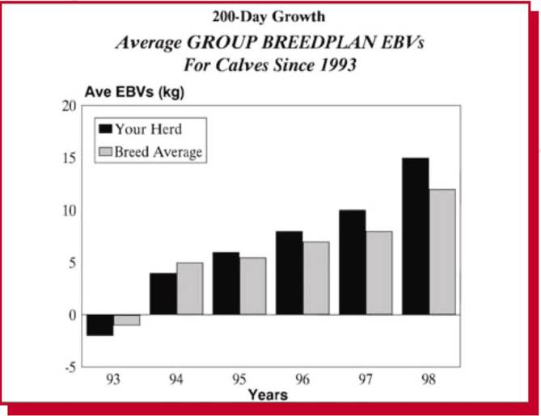

BREEDPLAN
genetics compared

BREEDPLAN ……
Can compare cattle across herds by using the genetic links that A1 sires create…

6.

Can animals be compared across herds?

Yes, BREEDPLAN is able to compare animals across herds provided there
are genetic links between the herds. The use of AI sires and the sale of
cattle from one herd to another provide these links. These links are
reinforced by the detailed pedigrees available in BREEDPLAN and breed
societies’ databases. Let's look at the example where cattle on 3 properties
A, B and C are compared. They all use a link sire by AI, and compare his
progeny with those of a different home sire on each property. Property A
is having a bad growing season, B average and C a very good growing season.

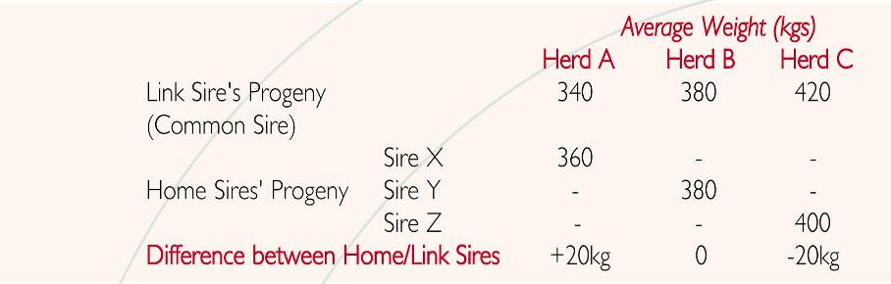

From the differences in the average weight of progeny from home sires and the link sire in each herd, we can see that herd sire X tested in herd A is superior to sire Y from herd B, which is superior to sire Z from herd C. (This assumes reasonable numbers of progeny measured and cows of equal performance. Adjustments are made if the cows are known to differ in performance on BREEDPLAN figures.) EBVs are then calculated from these progeny differences. In this example, if the link sire is a base animal, EBVs would approximate - X +40, Y 0, Z -40, ie. double the progeny differences as sires only contribute half the genes. This example also demonstrates that breeders should not be concerned that their EBVs will be depressed if they continue their recording programs during a poor growing season.

How often are GROUP BREEDPLAN EBVs calculated?
The computing of GROUP BREEDPLAN EBVs is very consumptive of computer resources, time (for supervision) and money (for publication of results). Most breeds, therefore, only have this done once or twice per year. A genetic "base" for the breed is determined as part of the GROUP BREEDPLAN run and EBVs of individual animals are calculated relative to the breed base.

What are Interim GROUP BREEDPLAN reports?
For some breeders, the scheduling of GROUP BREEDPLAN evaluations does not always coincide with their requirements for up-to-date EBVs. The INTERIM BREEDPLAN analysis is designed to meet this need. It is run for a nominated herd each time that herd submits additional calf performance records. The analysis uses the latest GROUP EBVs for the herd as a starting point, and updates the calf EBVs based on the extra performance information. These INTERIM EBVs can then be compared directly to the latest GROUP EBVs and INTERIM EBVs reported for other herds.

What research and development is behind BREEDPLAN?
Around R8 million per year is being invested in upgrading the BREEDPLAN evaluation procedures. This keeps the system on the leading edge internationally. Recently, a detailed evaluation of several million performance records were undertaken to calculate heritabilities and adjustment factors that are specific to the main beef breeds. These new factors have been included in the BREEDPLAN system to maximise the accuracy of the calculations. BREEDPLAN herds are also closely involved in major meat quality and breeding herd efficiency research projects. These have been collaboratively funded by the Australian Government, the Australian beef industry and four of Australia's research organisations to the tune of R350 million over seven years. These exciting projects have already provided important new technologies for inclusion in the BREEDPLAN services.

BREEDPLAN
how to use

BREEDPLAN ……
it becomes a part of your
normal management program

7.

How to use BREEDPLAN?

Use of the BREEDPLAN service is easy. The minimum requirements are:
Record birth dates
Tag calves
Record sire and dam of each calf
Weigh calves at least once, usually around 200 days.

That is, the fourth step is the only work additional to keeping normal breeding records.

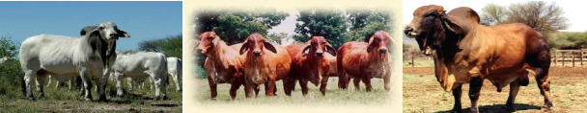

Please note that it is not necessary to weigh calves at birth. Both pedigree and commercial breeders can use BREEDPLAN effectively. It therefore becomes a part of your normal management program.

Of course, you can go a lot further and record the following optional information:
Birth weight and calving ease
400-day weights
Live animal fat and muscle ultrasound scans
Scrotal circumference
Date bull introduced to breeding cows
Carcase data from abattoirs
Temperament and other type traits

Most breeders start with the simple system and move into the options if and when they see a need for such options in their selection and marketing programs. If you are:
recording with a breed that has installed an integrated pedigree-performance system,
using AI to create genetic linkage to other herds, or
you have bought in most of your females from another BREEDPLAN recorded herd,

then you can successfully participate in GROUP BREEDPLAN with any number of females.
Once fully operational, breeders will be able to obtain a same day processing service by using Internet facilities.

What about Sale Catalogues?

The Society’s office will provide print-ready masters of sale catalogues on laser printer. These masters combine the pedigrees of cattle with their EBVs and accuracy values as calculated in the last GROUP BREEDPLAN run. The information is printed out in a standard format. By producing sale catalogues directly from the breed society databases errors in presentation can be minimised. This gives a boost in confidence to prospectively buyers of your stock.

Sale catalogues can also be displayed in the WEB from your breed society database. There is a powerful search engine that allows buyers to find lots that meet the requirements of their breeding programs.

BREEDPLAN
related services

BreedObject ……
the genetic selection aid.

8.

What is BreedObject?

BreedObject is a tool that can help you breed more profitable cattle.It helps
you target the type of commercial herd performance you need from animals
for a given market, and it helps you identify pedigree cattle that will be
best suited to this target. BreedObject is intended for both pedigree and
commercial beef producers.

The BreedObject technology was developed by the Animal Genetics and
Breeding Unit (AGBU), with financial assistance from Meat and Livestock
Australia. An economic weighting (based on costs of production and returns
on outputs), customised for each user and situation, is estimated for each
available EBV. The weighted EBVs are then combined into the single EBV,
which estimates the financial benefit from using any particular sire.

The Index values calculated by BreedObject describe how each animal is
expected to benefit commercial herd profitability when the production purpose
is as described. The Index value is an EBV for profit for performance in a commercial herd. Ranking pedigree animals on their Index values will sort them for their progeny's expected profitability for the production purpose chosen. Of course, you will still need to check sires for functional traits such as structural soundness and temperament to get the best results.

They will soon publish a Namibian Grassfed Indexes covering its various overseas and domestic markets. Some research will be required to apply this BreedObject index to cattle production systems but when this is completed the same flexible approach will be available.

Customised indexes can be calculated for individual herds using herd-specific production information and marketing goals. The herd only needs to answer some questions about the on-farm production and the requirements of the market being targeted. Providing indexes for clients is a valuable marketing tool for pedigree breeders.

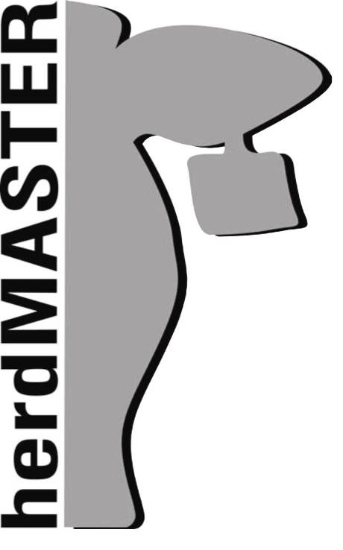 | What is HerdMASTER?  HerdMASTER is a leading-edge PC-based herd management system. It has been developed to be completely compatible with BREEDPLAN, and is supplied by Saltbush Software (the PC division of ABRI in Armidale).  Breeders who have supplied breeding and performance records to the Society can obtain a download of all animal records and EBVs relevant to their herd. This enables breeders to start using HerdMASTER with all pedigree and performance records already setup in the database.  HerdMASTER provides users with the ability to record new calves, weights and performance data, customised to meet ABRI and the Society’s requirements. Pedigree and performance information can then be sent to the Society via floppy disk or email, improving the integrity of data and saving both the breeder and Society time  and money!
BREEDPLAN
related services

HerdMASTER……
leading edge PC software for
on-farm data capture

9.

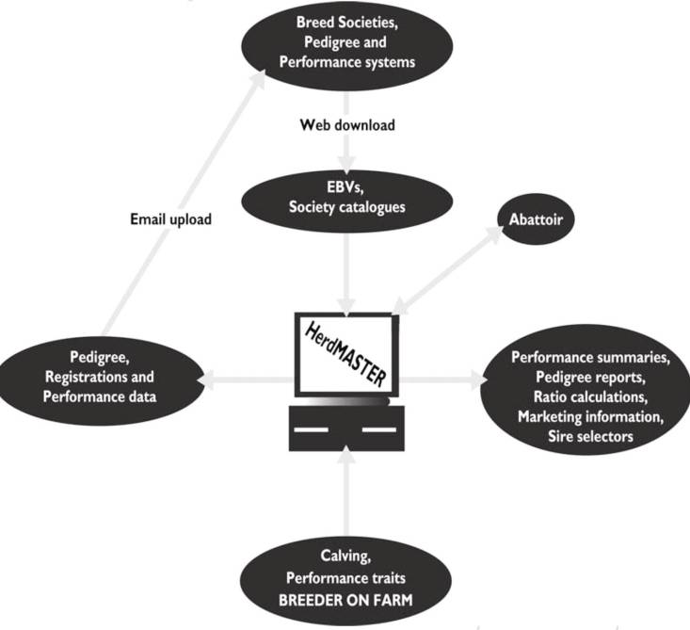

HerdMASTER keeps all herd details at your finger tips, eg. pedigrees, performance records, EBVs, veterinary treatments, sale details and a client mailing list. HerdMASTER is both a management and marketing aid, and is the most advanced herd management system of its type in the world.

What can HerdMASTER Offer?
Superior database performance and security
Improved efficiencies on-farm
Full industry integration
Improved profitability and herd management
Streamlined Herd Recording
Extensive reporting and analysis
Excellent technical support and training

HerdMASTER has been developed in the latest software technology from Microsoft. It can be
used in many configurations:
As a stand-alone on-farm PC application with email links to BREEDPLAN,
As a Pocket PC version for field collection of data,
As a central database, in which case users access on-farm via a browser.

The latter configuration is applicable to registered and commercial breeders who are participating
in a production/marketing alliance or in a supply management system.

More information on Herd MASTER can be obtained by visiting the
Webpage: http://www.breedplan.co.za
or by phone: +27 12 6675258
or Email at herdmaster@agribsa.co.za.

BREEDPLAN
related services

Internet Solutions……………
advanced internet
information system.

10.

Internet Solutions

BREEDPLAN has leading-edge internet facilities which ensure
that its users become part of a virtual world community of
cattle breeders.

The facilities include:
- Electronic herdbook enquiry service: all animals on the database
are included on ABRI's WEB server with a powerful engine that
allows enquires to undertake a wide range of functions including
searching pedigrees, printing performance pedigrees, ranking
animals for sale by the buyers' criteria and searching progeny,
- Membership enquiry system: allows an enquirer to search the
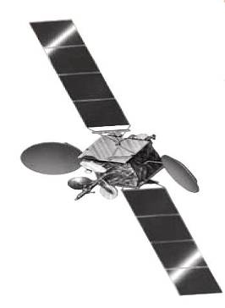
membership files directly for relevant contacts.
- Sale catalogue facility (public auction): sale catalogues can be
formed for single-vendor and multi-vendor auction sales with
powerful search and enquiry facilities. Photos of cattle for sale
can be displayed. All pedigrees and performance are picked up
automatically from the database and are continuously updated as
EBVs (both GROUP and Interim) are updated. Searches can be
done across catalogues to rank animals for sale on say a particular
BreedObject Index,
- Private treaty sales: breeders that are not having an auction sale can
include details of registered and commercial cattle that they have for
sale. The BREEDPLAN software puts the seller in contact with an
interested buyer. The sale is then concluded by private treaty;
- Listing of AI sires: these can be listed for a year at a time. EBVs and accuracies are automatically updated as more information is analysed. This is a valuable service to the AI industry,
- Mating Prediction: list a bull and the female(s) which you are considering to put to that bull and the system predicts the EBVs of progeny,
- Report and Data downloads: individual breeders can log on with their respective passwords and they can pick up reports and/or EBV data files that have been computed for them,
- Custom Reports: breeders can customise the reports they require from the database on-line,
- Carcase feedback: the Brahman breed society uses the system to provide carcase feedback to commercial breeders. Other breeds will follow.
- Internet-based registrations: breeders can log on via their password and enter their registration applications. The system will do interactive checks on validity of these records and subsequently update correct entries as a batch update. This allows a breed society office to be open for business 24 hours per day, 365 days per year for a very small retainer cost.

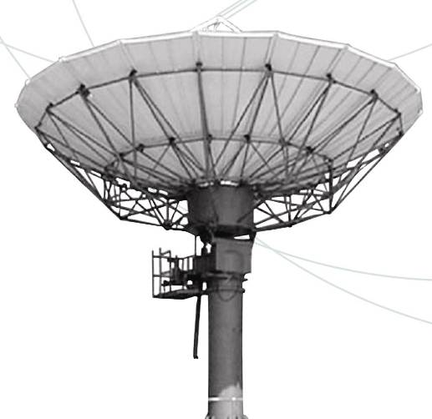
In 2007 this service attracted over 2.5 million enquiries

As a breeder, Internet Solutions
puts the details of your
genetics onto the world
market continuously.

BREEDPLAN
cost overview

BREEDPLAN…….
One of your lowest costs

11.

BREEDPLAN - What are the cost?

The annual cost of BREEDPLAN will depend on the costs incurred by the Society. As an example, a herd of 100 spring calving cows would generate the following annual income:

A 100-cow pedigree herd is likely to make the following annual sales (based on conservative prices):
20 registered bulls at R18 000 R360 000
7 registered heifers at R6 000 R 42 000
24 oxen at R3 800 R 91 200
10 cull heifers at R3 000 R 30 000
23 cull cows at R3 600 R 82 800

Total R606 000

For this herd of 100 cows, including a one day scanning visit, performance recording would be by far the cheapest of your
breeding and marketing costs, projected to be in the region
of just over 1% of expected gross annual income.
This is an important consideration because none of the investment
in feed, for example, is passed on to the next generation of calves!

Benefits of BREEDPLAN
Many herds are now producing sale progeny that are 10% heavier at the same age than before those herds began performance recording. To achieve that benefit for around 1% of sales revenue means a high benefit cost for BREEDPLAN. Benefit costs of around 15:1 are achieveable especially in herds which sell performance recorded stock at a premium for breeding purposes. These benefits will be further accentuated as you are able to make improvements in your herd's fertility and other selected traits through using BREEDPLAN.

Act Today!
In summary, BREEDPLAN is an inexpensive breeding tool that helps to put more cash in your pocket - irrespective of whether you are breeding registered or commercial livestock or both. BREEDPLAN provides breeders with better information with which to make decisions about their breeding programs. That's what's so good about it. That's why it's been such a success internationally.

BREEDPLAN is available from:
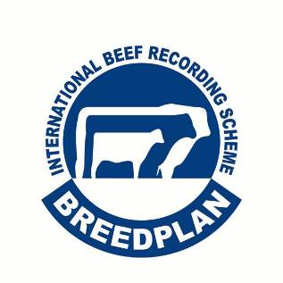
Postal Address
The Namibian Brahman Breeders Society
PO Box 11790
Klein Windhoek
Windhoek
Namibia
Telephone: +264-61-240 573
Fax: +264-61-240 573
Website: www.brahman.iway.na

BREEDPLAN / HerdMASTER
AgriBSA Software
Suite 301
318 The Hillside
Lynnwood

P O Box 543
Irene
0062

Tel: 086 111 5005
Fax: +27 12 667 5259
e-mail: herdmaster@agribsa.co.za
website: www.breedplan.co.za

